REGULAR EXPRESSION

regular Exp //

[abc] -> matches only that character inside of square bracket
[a-z A-Z]

[0-9] -> same it matches only the character lying b/w 0 to 9

[^a-zA-Z] -> the ^ inside square bracket means it doesnot match otherwise all the characters

inside of sqaure bracket matches

RANGES

/[0-9]{11}/ -> this means it matches only the number and the length of number must be <b>11</b>

[a-z]{minimum , maximum}

/[A-Z]{2,7}/ = This means it matches only Upper case letters and minimum length is 2
and max to 7

/[a-z]{6, }/ = This means it matches only lower case letters and minimum length is 6
and max to infinity

META CHARACTERS

\d same as [0-9]

\w == matches any word ->same as (a-z , A-Z , 0-9 , _ (underscores) )

\s -> matches any whitespaces [spaces and tabs]

Examples

[a-zA-Z\s]This regular expression matches any lower ,Upper
and whitespaces Characters

\d{3}\s This regular exp means type and digit of length exactly 3 and take gap

\t -> tab character only

SPECIAL CHARACTERS

REMEMBER! if we add these special character in our regular expression

there meanings are change make sense ! BUT if we want to use it actually use it with

back slash "\"
Examples

abc. -> this match an expression contain abc with any character except new line character
abc5 [matches] abc%[matches] etc....

abc\. -> it matches an actual word "abc."[match]

</p>
<p>

+ -> THe one or more quantifier

Examples

"Phone Authentication"
[0-4]+-[0-9]{7} -> This means that first it find any digit b/w 0 to 4 then it finds "-"
sign and it last find digit b/w 0 to 9 [the length of 0-9 must be 7 characters]
<b>\</b> -> Escape Characters

<b>[]</b> -> write anything and it start matches

<b>[^]</b> -> Not

<b>?</b> -> if we place this symbol it means it may or maynot neglect the last character
<b>e.g</b>
fareena? -> it matches "fareen" or "fareena" b/c the last character is optional

far?eena -> ans is:faeena OR fareena

. ->Any character except new line Character
* -> It is optional means many time or infinity
STARTING AND ENDING:(usually use when we donot want to take gap )

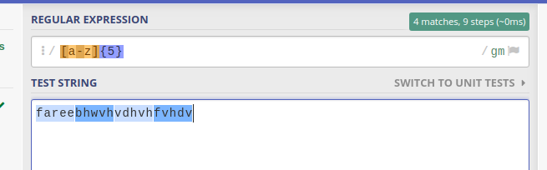
in this regex we only type lower
case letters and length must be of
5. Okay but we only want to
match first 5 letters nothing
more then that

so we use starting and ending pattern
^[a-z]{5}$ → This matches the first 5 letters

OR OPERATOR:
p|y → This means the expression finds p or y when an expression contain “p” first then it matches and not match “y”

